**JSS MAHAVIDYAPEETHA**



**Mini Project / Internship Assessment**

|  |
| --- |
| **Subject Name: Mini project / Internship Assessment**  **Subject Code : KCS-554** |

COURSE: B.Tech. SEMESTER: V

By-

Name: Kartikeyea Singh

Roll No: 1900910100077

**Department of Computer Science and Engineering**

**JSS ACADEMY OF TECHNICAL EDUCATION**

**C-20/1, SECTOR-62, NOIDA**

**2021-22**

**VISION AND MISSION**

**VISION OF THE INSTITUTE**

**JSS** **A**cademy of **T**echnical **E**ducation Noida aims to become an Institution of excellence in imparting quality **O**utcome **B**ased **E**ducation that empowers the young generation with **K**nowledge, **S**kills, **R**esearch, **A**ptitude and **E**thical values to solve **Contemporary Challenging Problems.**

**MISSION OF THE INSTITUTE**

**D**evelop a platform for achieving globally acceptable level of intellectual acumen and technological competence

**C**reate an inspiring ambience that raises the motivation level for conducting quality research

**P**rovide an environment for acquiring ethical values and positive attitude

**VISION OF THE DEPARTMENT**

“To spark the imagination of the Computer Science Engineers with values, skills

and creativity to solve the real-world problems.”

**MISSION OF THE DEPARTMENT**

To inculcate creative thinking and problem-solving skills through effective teaching, learning and research.

To empower professionals with core competency in the field of Computer Science and Engineering.

To foster independent and lifelong learning with ethical and social responsibilities.

**PROGRAM OUTCOMES (POs)**

**Engineering Graduates will be able to:**

**PO1: Engineering knowledge**: Apply the knowledge of mathematics, science, engineering fundamentals, and an engineering specialization to the solution of complex engineering problems.

**PO2: Problem analysis**: Identify, formulate, review research literature, and analyze complex engineering problems reaching substantiated conclusions using first principles of mathematics, natural sciences, and engineering sciences.

**PO3: Design/development of solutions**: Design solutions for complex engineering problems and design system components or processes that meet the specified needs with appropriate consideration for the public health and safety, and the cultural, societal, and environmental considerations.

**PO4: Conduct investigations of complex problems**: Use research-based knowledge and research methods including design of experiments, analysis and interpretation of data, and synthesis of the information to provide valid conclusions.

**PO5: Modern tool usage**: Create, select, and apply appropriate techniques, resources, and modern engineering and IT tools including prediction and modeling to complex engineering activities with an understanding of the limitations.

**PO6: The engineer and society**: Apply reasoning informed by the contextual knowledge to assess societal, health, safety, legal and cultural issues and the consequent responsibilities relevant to the professional engineering practice.

**PO7: Environment and sustainability**: Understand the impact of the professional engineering solutions in societal and environmental contexts, and demonstrate the knowledge of, and need for sustainable development.

**PO8: Ethics**: Apply ethical principles and commit to professional ethics and responsibilities and norms of the engineering practice.

**PO9: Individual and team work**: Function effectively as an individual, and as a member or leader in diverse teams, and in multidisciplinary settings.

**PO10: Communication**: Communicate effectively on complex engineering activities with the engineering community and with society at large, such as, being able to comprehend and write effective reports and design documentation, make effective presentations, and give and receive clear instructions.

**PO11: Project management and finance**: Demonstrate knowledge and understanding of the engineering and management principles and apply these to one’s own work, as a member and leader in a team, to manage projects and in multidisciplinary environments.

**PO12: Life-long learning**: Recognize the need for, and have the preparation and ability to engage in independent and life-long learning in the broadest context of technological change.

**PROGRAM EDUCATIONAL OUTCOMES (PEOs)**

**PEO1**: To empower students with effective computational and problem-solving skills.

**PEO2:** To enable students with core skills for employment and entrepreneurship.

**PEO3**: To imbibe students with ethical values and leadership qualities.

**PEO4:** To foster students with research-oriented ability which helps them in analyzing and solving real life problems and motivate them for pursuing higher studies.

**PROGRAM SPECIFIC OUTCOMES (PSOs)**

PSO1: An ability to apply foundation of Computer Science and Engineering, algorithmic principles and theory in designing and modeling computation-based systems.

PSO2: The ability to demonstrate software development skills.

**COURSE OUTCOMES (COs)**

|  |  |
| --- | --- |
| **CO1** | Undertake problem identification, formulation and design a solution |
| **CO2** | Solve the real-world problems effectively and adapt with real life working environment. |
| **CO3** | Acquire skills and knowledge on latest tools and technologies |
| **CO4** | Develop effective communication skills for presentation of project related activities |
| **CO5** | Effectively communicate solution to problems through technical reports |

**CO-PO-PSO MAPPING**

|  |  |  |  |  |  |  |  |  |  |  |  |  |  |  |
| --- | --- | --- | --- | --- | --- | --- | --- | --- | --- | --- | --- | --- | --- | --- |
|  | **PO1** | **PO2** | **PO3** | **PO4** | **PO5** | **PO6** | **PO7** | **PO8** | **PO9** | **PO 10** | **PO 11** | **PO 12** | **PSO1** | **PSO2** |
| **CO1** | 3 | 3 | 3 | 3 | 2 | 3 | 3 | 3 | 3 | 3 | 2 | 3 | 3 | 3 |
| **CO2** | 3 | 3 | 3 | 3 | 3 | 3 | 3 | 3 | 3 | 2 | 3 | 3 | 3 | 3 |
| **CO3** | 2 | 2 | 3 | 3 | 3 | 2 | 3 | 3 | 3 | 1 | 2 | 3 | 3 | 3 |
| **CO4** | 2 | 2 | 2 | 2 | 2 | 2 | 2 | 2 | 2 | 3 | 2 | 3 | 2 | 2 |
| **CO5** | 2 | 2 | 2 | 2 | 2 | 2 | 2 | 2 | 2 | 3 | 2 | 3 | 2 | 2 |
| **CO** | 2.40 | 2.40 | 2.60 | 2.60 | 2.40 | 2.40 | 2.60 | 2.60 | 2.60 | 2.40 | 2.20 | 3.00 | 2.60 | 2.60 |

## CERTIFICATE

This is to certify that Mini Project/Internship Assessment Report entitled “ECOMMERCE SHOPPING WEBSITE” which is submitted by KARTIKEYEA SINGH in partial fulfillment of the requirement for the award of degree B. Tech. in Department of Computer Science and Engineering of Dr. APJ Abdul Kalam Technical University, Uttar Pradesh, Lucknow is a record of the candidate’s own work carried out by him/her under my supervision. The matter embodied in this report is original and has not been submitted for the award of any other degree.

**Supervisor: MR. GIRISH KUMAR B C**

**Date: 6 Dec, 2021**

**DECLARATION**

I hereby declare that this submission is my own work and that, to the best of my knowledge and belief, it contains no material previously published or written by another person nor material which to a substantial extent has been accepted for the award of any other degree or diploma of the university or other institute of higher learning, except where due acknowledgment has been made in the text.

Signature: Kartikeyea Singh

Name : Kartikeyea Singh

Roll No. : 1900910100077

Date : 9/12/21

**ACKNOLEDGEMENT**

With immense please I, **MR. KARTIKEYEA SINGH** present “**ECOMERCE SHOPPING WEBSITE**” report as part of the **Mini Project Assessment** of ‘B.Tech. in Computer Science and Engineering’. I wish to thank all the people who gave me unending support.

I express my profound thanks to **MR. GIRISH KUMAR B C** supervisor of mini project. And all those who have indirectly guided and helped me in preparation of this mini project.

Kartikeyea Singh

1900910100077

CS2-B1

**ABSTRACT**

FASHION ECOMMERCE WEBSITE is the name of my project. In today's fast-paced corporate world, it's critical to be able to respond to client requests in the most efficient and timely manner possible.

Online Shopping is a lifestyle e-commerce website that sells a variety of fashion and lifestyle products (now Men's Wear). This project allows registered users to browse the many products offered and purchase them instantaneously using the PayPal payment processor (Instant Pay), as well as place orders utilizing the Cash on Delivery (Pay Later) option. Administrators and managers can easily view orders placed thanks to this initiative.

This is a project with the goal of creating a basic website with a shopping cart application for consumers, as well as learning about the technologies necessary to create such an application.

**TABLE OF CONTENTS**

* Introduction
* History
* Tools and technology used
* Feature of the technology used
* Industrial and Societal relevance and impact of the project
* Screenshots of the project
* Future Scope of the project
* Conclusion
* References
* Plagiarism report

**INTRODUCTION**

E-commerce is quickly becoming a widely accepted and used business model. More and more businesses are developing web sites that allow them to conduct commercial transactions over the internet. It is fair to argue that online purchasing is growing more common. The goal of this project is to create a general-purpose e-commerce store where people can buy things like garments from the comfort of their own homes over the Internet.

A virtual store on the Internet where clients can browse the catalogue and select products of interest is known as an online store. To collect the required things, a shopping cart can be utilized. The goods in the shopping cart will be displayed as an order at the moment of checkout. More information will be required at that time to complete the transaction. The customer will typically be prompted to fill out or select a billing address, a mailing address, a shipping option, and payment information such as a credit card number the customer receives an e-mail notification as soon as the order is placed.

**Overall description**

Any member can register and look at the products that are available.

Only registered members have the ability to purchase multiple products in any number.

If you have any questions, you may contact Admin using the Contact Us page.

Visitor, User, and Admin are the three jobs accessible.

• The visitor can look at the products that are available.

• Products can be viewed and purchased by the user.

• An Admin has additional privileges, including all visitor and user privileges. The administrator has the ability to add products, change product details, and add/remove items. Admin can create new users, modify their information, and delete them. Admin can ship order to user based on order placed by sending confirmation mail.

ONLINE SHOPPING APPLICATION: Anyone can explore the Online Shopping site and available products, but in order to purchase or order products, each user must connect with his or her Username and password. Members who have not yet registered can do so by going to the registration page. Only Admins will be able to change roles, and developers can only be 'Admins' by default. When a user registers on the site, his default role is 'User.'

HOMEPAGE: The Home Screen will be a screen where you can browse the products available on our website.

CLOTHING PAGE: This page offers information on the product. Both visitors and users see the same version of this page.

ORDER US PAGE: Here, registered users can order the things they want.

ABOUT US PAGE: This page provides information about the website and its proprietors.

REGISTER PAGE: Here is where new users can sign up.

LOGIN PAGE: Both users and administrators utilize this page to log in.

ORDER VIEW FOR USER: Users can see the ordered products and total once they place an order.

PAYPAL FOR PAYMENT: Users are led to the payment page after placing an order.

**History**

The history of ecommerce began more than 40 years ago, when early technology such as In the 1970s, teleshopping and electronic data interchange (EDI) were developed, paving the way for the modern-day ecommerce business as we know it today.

The history of ecommerce is inextricably linked to that of the internet. When the internet was first made available to the general public in 1991, online purchasing became conceivable. Thousands of companies have now followed in Amazon's footsteps, which was one of the first ecommerce sites in the United States to start selling things online.

**Tools & Technology Used**

**Sublime Text 3**

Sublime Text 3 is a text editor that is widely used, fast, and simple to use. On your computer, it basically lets us to generate and edit a wide range of programming language files. The code is written in sublime text and saved with the appropriate extension before being run. Sublime Text assists with text indentation.

**HTML (Hyper Text Markup Language)**

HTML stands for Hyper Text Markup Language and is a markup language that is extensively used to construct web pages. This is the language that computers use on the internet to interact with one another. The browser displays the Hyper Text Markup Language content. Browsers have their own system for detecting web languages, with HTML serving as the foundation. HTML is used to define a web page's structural framework.

Tags are the building blocks of HTML elements. Tags are specified terms in simple language. An HTML element is initialized by a start tag (format: <abc>), some content and an end tag (format: </abc>).

**Basic framework of an HTML Page-**

<! DOCTYPE html> - This tag is used to specify the language HTML 5.

<html> - This tag signals that from here we are going to write in HTML code.

<head> - In this metadata is stored.

<title> - It contains page name that will appear on the top of browser window or tab.

<body> - Here all the content is written.

**Visual structure of an average HTML page.**

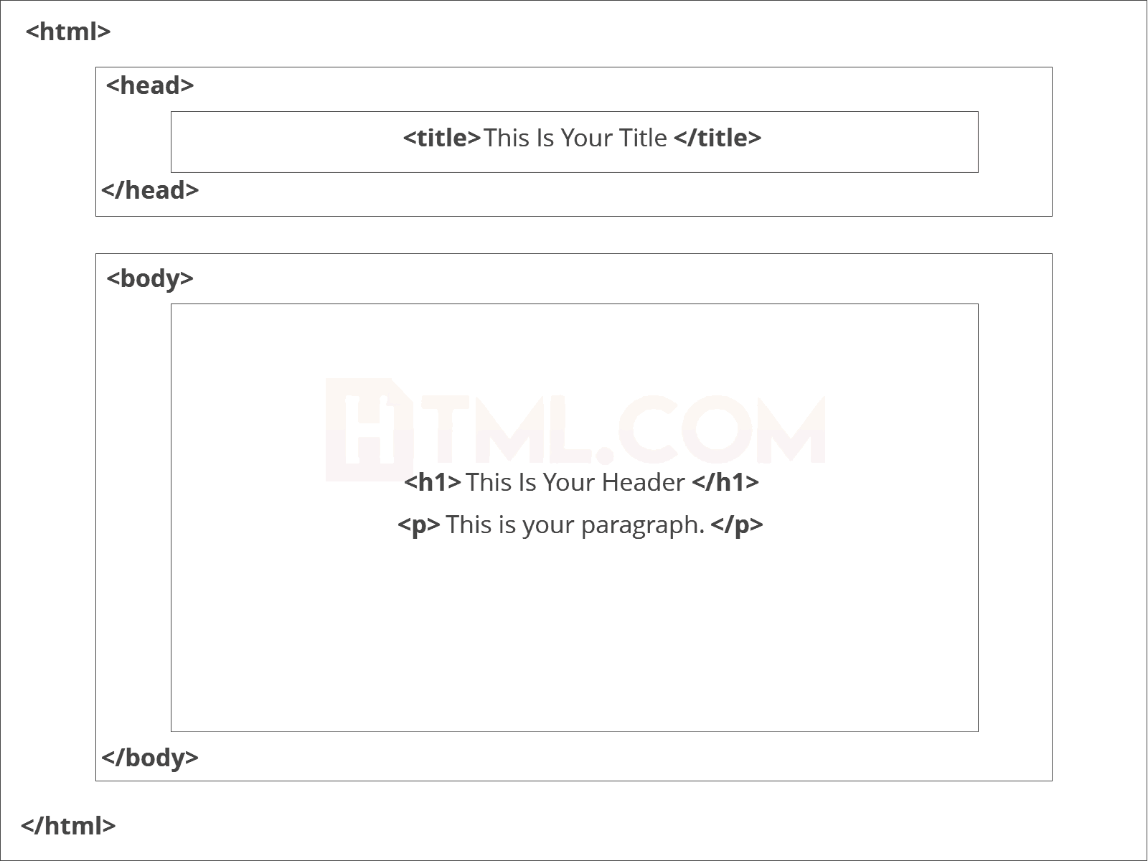

**CSS (Cascading Style Sheets)**

CSS is an acronym for Cascading Style Sheets. CSS specifies how HTML elements should appear (look and feel) on a screen, on paper, or in other medium. CSS code can be used multiple times in the same or various HTML files, saving both space and time. CSS is an easy-to-learn and understand style sheet language that gives an HTML text a considerable advantage in terms of display. Inline, internal, and external are the three ways to define CSS in an HTML file.

Inline styles are written straight into the HTML tags using the style attribute. Internal styles are used for the whole page. Inside the head element, the style tags encapsulate all of the styles for the page. While the external styles are used for the whole, multiple page website. This is a separate CSS file which is saved as “.css” in the same directory as your HTML page. Then it is linked to the desired HTML page.

**JavaScript**

JavaScript is a popular and rapidly expanding client-side scripting language. It's used to write a website's logic. JavaScript is the only programming language that can be used to create frontend code for websites, mobile apps, and even games. It is a dynamic language with several built-in libraries that offer functions for real-world problems that programmers can utilise to make their jobs easier. We can write JavaScript code in an HTML file using a script element to isolate the JavaScript code from the HTML code, or we can write and save a script in another external text file with the extension '.js'. The src property of the opening script element can then be used to call it from the HTML code.

**Java VS JavaScript**

Java is an object-oriented programming language that can be run on a virtual computer or in a web browser. Java's code is compiled before it is executed, and it is a static type language. JavaScript is a dynamic language that runs only in the browser and is an OOP scripting language that runs only in the browser.

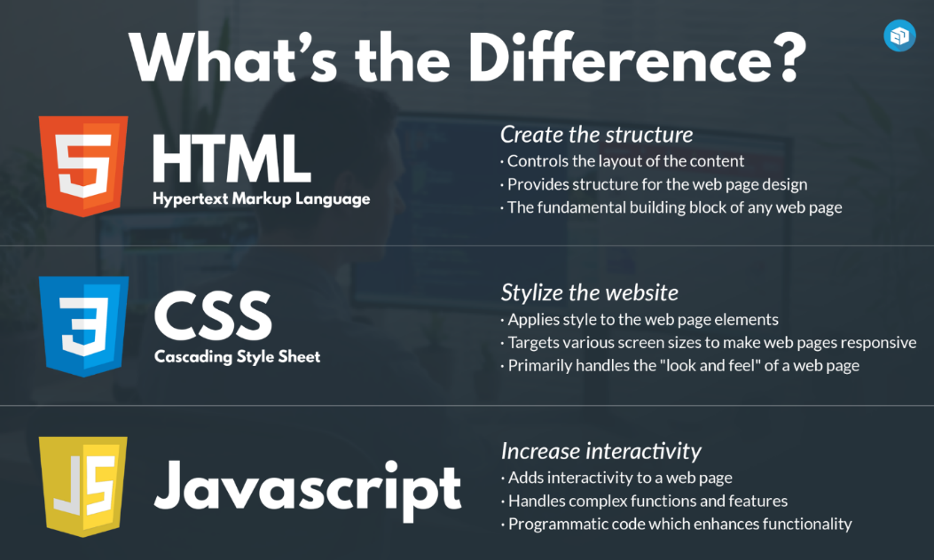

**Python (using Anaconda Navigator)**

Python is a widely used high-level, interpreted programming language for a variety of purposes. Anaconda is a Python distribution that tries to make package management and deployment easier. The HTML script is called and the application is launched in the browser using python.

**Web Search**

A search engine is used to do web searches. A search engine aids in the organization of internet data. During the course of this project, I conducted numerous searches in order to obtain various project skills and expertise. Online searches are quick, inexpensive, and simple to locate and utilize.

**Alternative for technology used**

Yes, there are numerous alternatives to the various technologies used here. Elm is a programming language that substitutes HTML, CSS, and JavaScript. It is simpler to use and learn, but the biggest disadvantage is that certain of its features are not supported by a few search engines because they are still being developed.

Instead of JavaScript, we can use PureScript and ClojureScript, which are both enjoyable to use. However, I have not utilized it because it is not widely used among college students and beginning.

Visual Studio is a Windows-based IDE (Integrated Development Environment) for creating web pages, online applications, web services, and programmers. As an alternative to Sublime Text 3, we may edit text with Visual Studio, Notepad++, Jupyter Notebook, Spyder, and a slew of other programmers.

Books (on web development, HTML, CSS, and JavaScript) are the greatest alternatives to web searches since they provide a detailed overview of the history, operation, and logic of these programming languages and subjects.

**Why was the technology chosen?**

I opted to perform my research on the web rather than browsing through books for knowledge and skills for the completion of my mini project because web searches were quick and I was able to grasp them through online lectures, YouTube, and articles on the internet. It was also affordable, and with just one click, I was able to clear up several of my doubts.

Because I've been using Sublime Text as a text editor for creating code for my programmers for a long time, I'm familiar with its UI (User Interface), which is why I chose it over other text editors.

I picked HTML, CSS, JavaScript, and Python to construct the game because these languages have a lot of online resources and were also simple to learn. Furthermore, these languages are currently popular among web designers in a variety of firms for web development.

**History and features of the technology used**

**History of the technology used**

Jon Skinner created Sublime Text after quitting his job as a software developer at Google to pursue his passion of creating a better text editor. The first version of Sublime Text was released on January 18, 2008.

Tim Berners-Lee developed the first version of HTML in 1993. After that, many alternative versions of HTML were established, the most widely used of which was HTML. In December 1999, it was made an official standard.

CSS was proposed to address the problem of web style sheets. On October 10, 1994, Hakon Wium Lie proposed it for the first time.

Brandan Eich, a Netscape programmer, created a new programming language in under ten days in September 1995. It was originally known as Mocha, but it was quickly renamed LiveScript, and then JavaScript.

Python was first introduced in December of 1989. It was created by Guido van Rossum as a successor to the ABC programming language at Centrum Wiskunde and Infromatica in the Netherlands.

**Features of the technology used**

**Sublime Text**

Go to anything and any definition.

Multiple selections.

Command palette.

API ecosystem with a lot of power.

Cross platform.

Fast speed and better indentation.

**HTML 5**

Video and Audio tags.

It requires less effort to learn and use.

Placeholders.

It is platform independent.

**CSS**

The framework of a web page is better handeled.

It has better device compatibility.

Ability to Re-Position.

When style (CSS) and structure (HTML) are kept separate, the file size is reduced.

**JavaScript**

Object-Centered Script Language.

Client edge Technology.

Validation of User's Input.

Else and If Statement.

Interpreter Centered.

Ability to perform In Built Function.

Case Sensitive format.

Light Weight and delicate.

**Python (using anaconda navigator)**

Compiled with latest python release (anaconda).

Python is object oriented language.

It is high level portable language.

New and wide range of packages.

**Industrial Relevance of the Technology used**

All of the technologies employed play a critical role in the industries. Web development services can make use of them. These services assist the company in improving product expertise, maintaining communication with potential consumers, selling items or services, and increasing the company's popularity. These languages are also utilized in Artificial Intelligence and Machine Learning, two fields with a wide range of applications. HTML, CSS, and JavaScript can be used to create websites, apps, and online services. Companies create online games and apps, which are then distributed to customers through various app stores. Websites aid in the advertising of a business's services and goods as well as providing client feedback via online surveys, which are two-thirds faster than traditional survey methods. Many applications are used by industries to recruit desired staff. Many online applications are used to keep data in cloud storage, for communication and also for data management and attendance.

**Societal Relevance and Impact of the Project**

**Advantages of e-Commerce to Customers**

* Provide details of the virtual showcase on websites with online catalogs.
* Due to competitions, prices have been reduced (coupons and offers).
* Access and convenience 24 hours.
* Ensure the safety of business transactions.
* It is easier to compare prices with other premium brands.
* Many options and range (options and options).
* Return products if it is of lower quality.
* Time-savings and easy-to-read reviews.

**Advantages of e-Commerce to Business**

* Increase in potential market share by increasing the customer base
* Low barriers to items
* Business transactions that are secure and quick.
* Participate in retail for the launch of new products and services
* 24/7, 365 days of sales (buyer and seller)
* Expanding the scope of the business
* Main warehouse administration
* Reduction of employee costs

**Disadvantages of e-Commerce for Customers**

* Unable to personally examine the products
* Privacy and security in online purchases
* Fraud with credit cards
* Delays in receiving products
* Inability to identify fraud
* Guarantee/guarantee
* Quality
* Hidden cost
* Lack of personal interaction
* Website fraud.

**Disadvantages of e-Commerce to Business**

* Update your gear and software on a regular basis.
* Website maintenance at a periodic interval
* For electronic commerce infrastructure, there are additional expenditures and expertise.
* The readiness of the site
* Training and maintenance Customer loyalty
* Outstanding logistics needs
* Security and credit card issues
* Fraudulent orders
* Sufficient internet services

**Screenshots of the project**

**Website Home Page**



**Registration and login page**



**Product page**

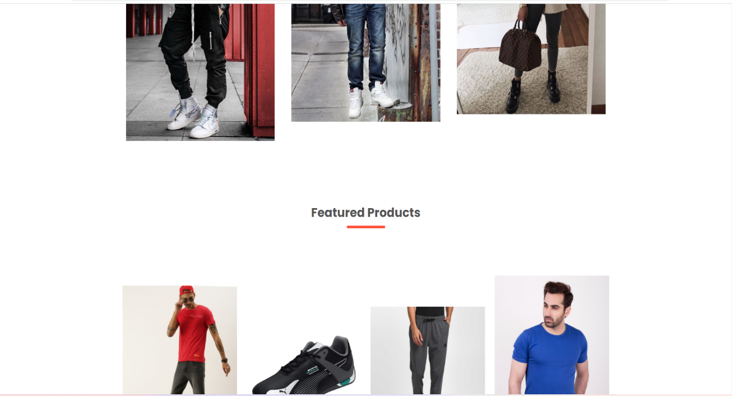

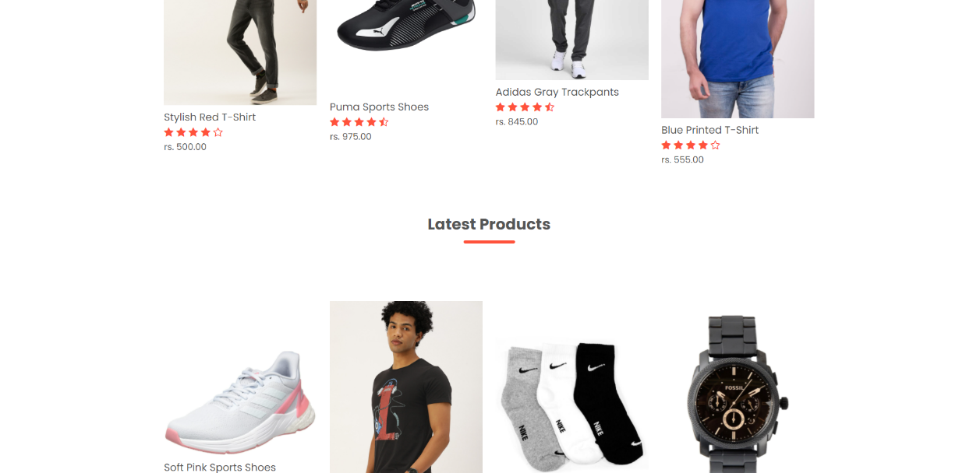

**Customer Top Review’s**

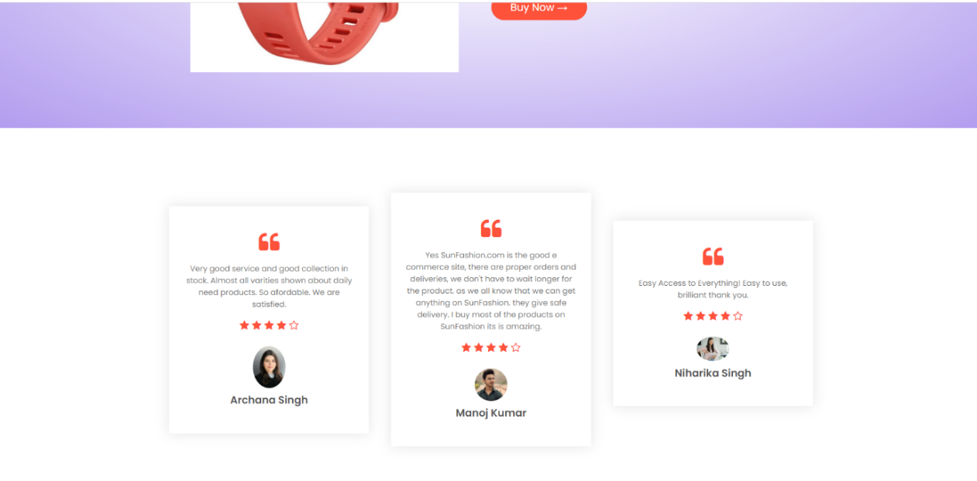

**My Cart**

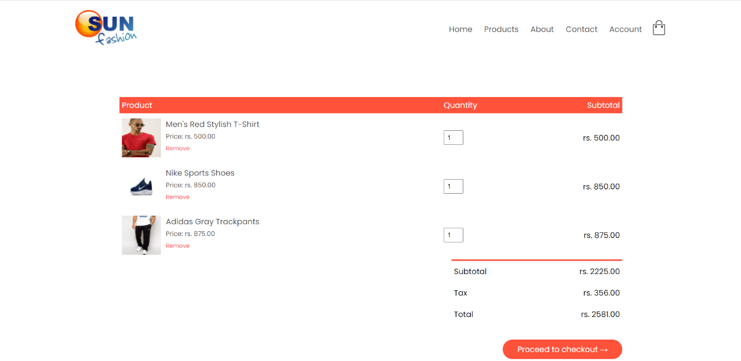

**Top Partner’s**

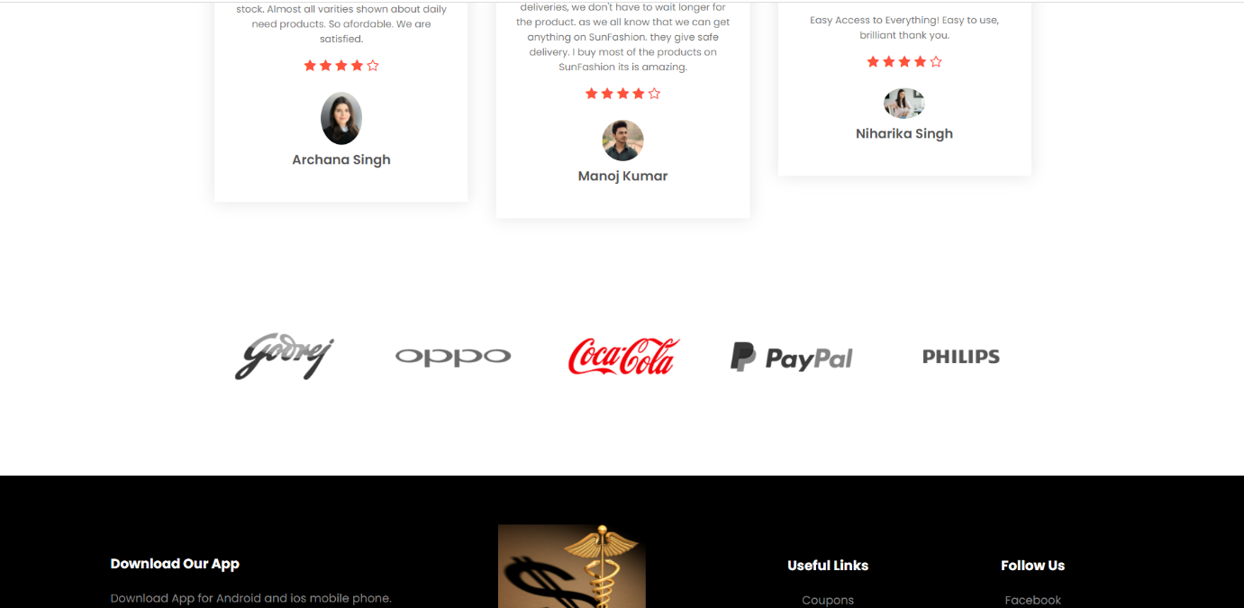

**Future Scope of the Project**

The future of e-commerce in India is enormous, and the ever-increasing penetration of smartphones will only fuel the expansion. As the e-commerce industry sees increased traction, it is expected to **increase to reach a market size of US$ 188 billion by 2025**. The scope of ecommerce has been extended to the next level when **dealing online.** E commerce is simply the act of purchasing and selling goods through the internet. It encompasses the entire internet development, marketing, selling, and delivery process in India has third largest internet population in the world and growing at unprecedented price. In India Cash on Delivery is the preferred buying method, E-commerce creates new opportunities to job seeker.

**Conclusion**

Electronic shopping has gained importance not only from the standpoint of the entrepreneur, but also from the standpoint of the customer, since the Internet has become a vital resource in modern business. Electronic shopping opens up new business prospects for the entrepreneur, and it allows customers to compare prices. According to a report, most internet shoppers are impulsive and decide whether or not to stay on a site within the first few seconds. "Website design is similar to the interior design of a store." If the shop appears to be run-down or similar to hundreds of others, the customer is likely to move on to another site. As a result, we created the project to give the user as much ease of navigation, data retrieval, and essential feedback as feasible. The user is given with an ecommerce web site that can be utilized to purchase books online in this project. A user-friendly shopping cart application logic must accompany a decent shopping cart design. Viewing the contents of the customer's cart and being able to remove or add goods to the cart should be simple. The shopping cart application for this project incorporates a number of features targeted at improving the customer's experience. This project will help you understand how to make an interactive web page and the technology that go into making it.

**References**

[HTML Tutorial (w3schools.com)](https://www.w3schools.com/html/)

[CSS Tutorial (tutorialspoint.com)](https://www.tutorialspoint.com/css/index.htm)

[e-commerce web site project (slideshare.net)](https://www.slideshare.net/mhasan2999/ecommerce-web-site-project)

[E-commerce - Wikipedia](https://en.wikipedia.org/wiki/E-commerce)

[Build Responsive Websites with HTML5 and CSS3 | Udemy](https://www.udemy.com/course/design-and-develop-a-killer-website-with-html5-and-css3/?matchtype=e&msclkid=4795737fdf51125bf9f412c575ed8ff3&utm_campaign=BG-LongTail_la.EN_cc.INDIA&utm_content=deal4584&utm_medium=udemyads&utm_source=bing&utm_term=_._ag_1209463203435778_._ad__._kw_CSS+Training_._de_c_._dm__._pl__._ti_kwd-75591788369226%3Aloc-90_._li_154841_._pd__._)

[Responsive Ecommerce Website Using HTML CSS JAVASCRIPT (How To Make An e-commerce Website) - Bing video](https://www.bing.com/videos/search?q=how+to+make+a+ecommerce+website&&view=detail&mid=7968898624A9062574CC7968898624A9062574CC&&FORM=VRDGAR&ru=%2Fvideos%2Fsearch%3Fq%3Dhow%2Bto%2Bmake%2Ba%2Becommerce%2Bwebsite%26FORM%3DHDRSC3)